Average waiting times
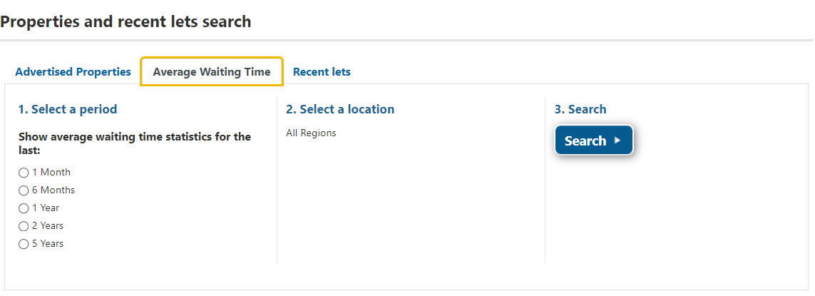
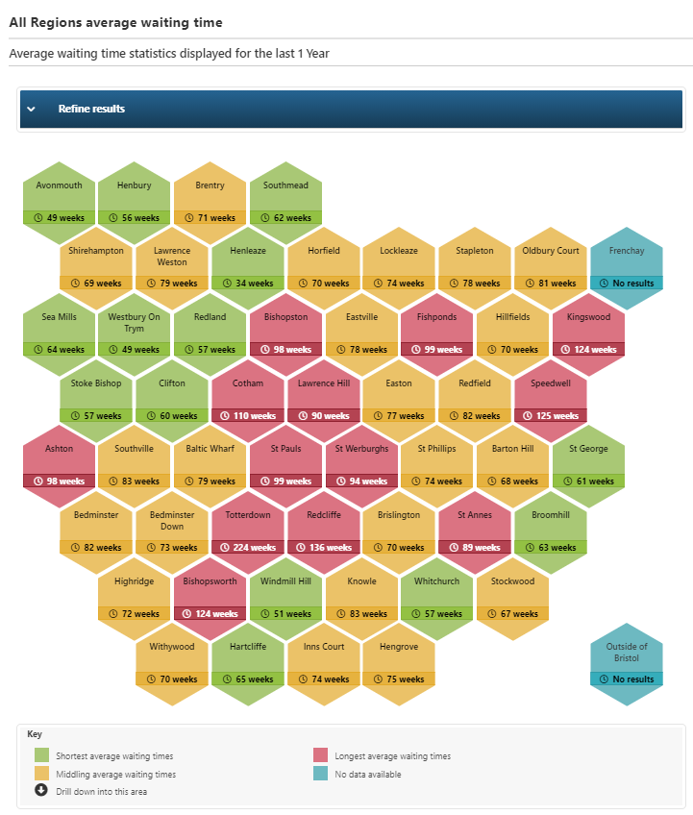
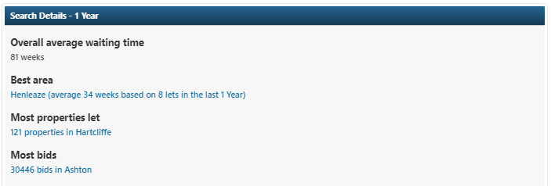

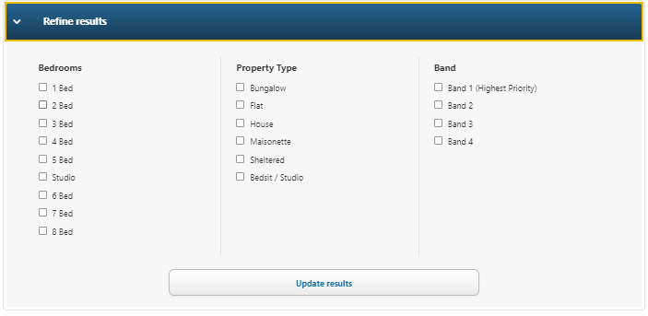

Go to the new Average Waiting Time tab and select the period you wish to see e.g. 1 Year, then click Search

The map is reprenstative of Bristol and some areas are grouped together as they are small. Click on any hexagon that you are interested in to see more information about the recent lets in that area.

Some useful information is also displayed at the bottom of the page.

You can refine your results by opening the “refine results” box. You can choose to select as many options as you wish. Click update results and see the data in the map change.

Grouped areas

Southmead includes Filton
Sea Mills includes Coombe Dingle
Horfield includes Manor Farm
Bishopston includes Ashley Down
Eastville includes Whitehall & Greenbank
Stoke Bishop includes Sneyd Park
Cotham includes St Andrews
Baltic Wharf includes Temple Quay, Wapping Wharf, Spike Island
St Pauls includes St Judes, Stokes Croft, Montpelier, Kingsdown
St Werburghs includes St Agnes
St Phillips includes Old Market
Highridge includes Headley Park

