# Translation function in Abritas v13

## Microsoft Edge browser

Open the [www.homechoicebristol.co.uk](http://www.homechoicebristol.co.uk) website using Edge browser. On any page you can right click and this will give you the option to choose translate

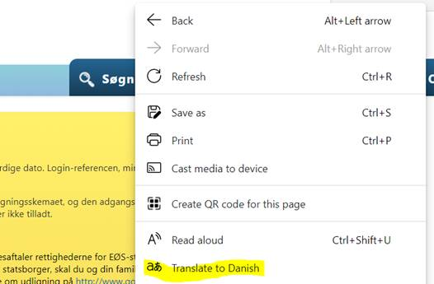

It places a widget at the right hand side of the URL



Click on it and you can choose which language you want to use

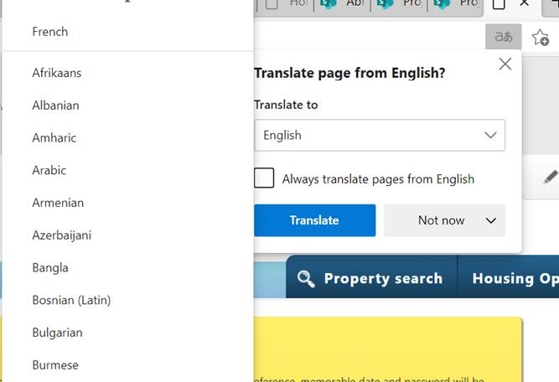

## Google Chrome browser

Open the [www.homechoicebristol.co.uk](http://www.homechoicebristol.co.uk) website using Chrome browser. On any page you can right click and this will give you the option to choose translate

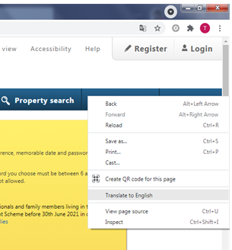

It places a widget at the right hand side of the URL



Click on the widget and the following will appear, click on the 3 dots on the right side

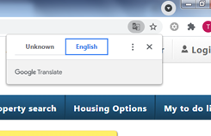

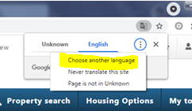

Click on Choose another language and select the language from the dropdown list – as shown

